Definitions

1. **Culture**: The values and beliefs of a group of people and how you act as a person
2. **Anthropology**: The study of all things people
   1. **Cultural:** the study of human societies and cultures and their development.
   2. **Linguistic:** Study of humans and how they communicate with one another
   3. **Archaeology:** Study of human history and prehistory through the excavation of sites and the analysis of artifacts and other physical remains.
   4. **Biological**
      1. **Physical:** the study of human biological and physiological characteristics and their development.
         1. **Paleoanthropology:** concerned with fossil hominids. (**Related: paleoclimatology**)
         2. **Skeletal Biology/Osteology:** Study of the physical body as it relates to human growth and physiology
         3. **Paleopathology/Bioarchaeology:** pathological conditions found in ancient human and animal remains (**Related: archaeology**)
         4. **Forensic:** Study of human remains with a legal context
      2. **Primatology:** Study of primates and other humanoid creatures
      3. **Human Biology/Behavioral Ecology:** Human growth and development to environmental extremes; behavior due to ecological pressure (famine, flood, etc)
      4. **Medical:** the study of how people in different cultural settings experience health and illness.
      5. **Evolutionary Psychology:** Design of the human mind as a result of recurrent selection pressures (natural selection’s effect on the human psyche)
3. **Biology:** Study of living organisms
4. **Science:** A process in which empirical data is collected to either prove/disprove a given claim (hypothesis)
5. **History of Scientific Thought:** people had simple minds then realized they needed to think more now we have advanced techniques to study shit
   1. **Immutability:** Species do not change, they are static
   2. **Uniformitarianism:** that changes in the earth's crust during geological history have resulted from the action of continuous and uniform processes
   3. **Catastrophism:** that changes in the earth's crust during geological history have resulted chiefly from sudden violent and unusual events
   4. **Lamarck:** Traits that are used or disused
   5. **Linnaeus:** a Swedish botanist who created the current system for classifying plants and animals.
   6. **Taxonomy/Binomial Nomenclature:** Grouping organisms into units; *Homo sapiens* (Humanoids)
      1. **Phylogenetics/Systematics:** relating to the evolutionary development and diversification of a species or group of organisms, or of a particular feature of an organism.
      2. **Cladistics/Parsimony:** a method of classification of animals and plants according to the proportion of measurable characteristics that they have in common
         1. **Ancestral (traits):** a *trait* shared by a group of organisms as a result of descent from a common *ancestor*
         2. **Derived (traits):** that is present in an organism, but was absent in the last common ancestor of the group being considered
         3. **Clade:** a group of organisms believed to have evolved from a common ancestor
      3. **Cladogram vs. Phylogenetic Tree**
         1. **Cladogram:**  a branching diagram showing the cladistic relationship between a number of species.

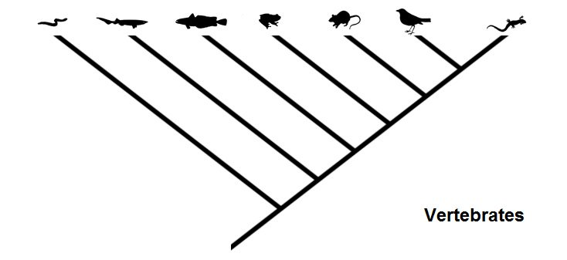

* + - 1. **Phylogenetic Tree:**  a diagram showing the evolutionary interrelations of a group of organisms derived from a common ancestral form. 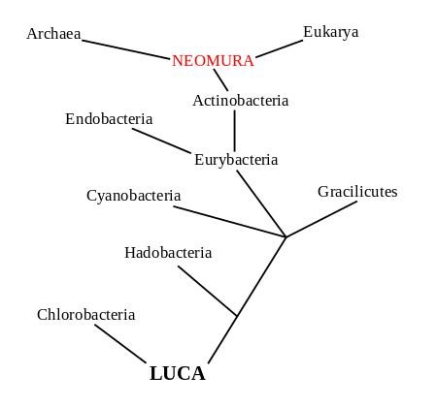
    1. **Genetic Distance:**